48 x 18 x 69" Mobile Shelving
  
  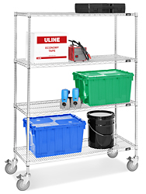
  HEAVY DUTY
  Tough, maneuverable carts move large loads.
  - 4 Shelf – Longer posts give more space for larger items. Greater capacity for less trips.
  - Easy to clean; won't collect dirt.
  - Shelves adjust in 1" increments.
  - 5" locking swivel casters included.
  - NSF certified.
  - Optional Wire Shelving Accessories available.

MODEL  NO. | DIMENSIONS  W x D x H | SHELF  QTY. | CAPACITY  (LBS.) | PRICE EACH |  | WT.  (LBS.) | ADD TO  CART
 |  |  |  | 1 | 3+ | WT.  (LBS.)
H-3156 | 48 x 18 x 69" | 4 | 1,000 | $229 | $219 | 76

SHIPS UNASSEMBLED VIA UPS

48 x 24 x 69" Mobile Shelving
  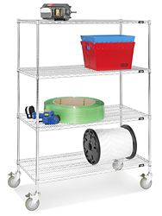
  Enlarge
  HEAVY DUTY
  Tough, maneuverable carts move large loads.
  - 4 Shelf – Longer posts give more space for larger items. Greater capacity for less trips.
  - Easy to clean; won't collect dirt.
  - Shelves adjust in 1" increments.
  - 5" locking swivel casters included.
  - NSF certified.
  - Optional Wire Shelving Accessories available.

MODEL  NO. | DIMENSIONS  W x D x H | SHELF  QTY. | CAPACITY  (LBS.) | PRICE EACH |  | WT.  (LBS.) | ADD TO  CART
 |  |  |  | 1 | 3+ | WT.  (LBS.)
H-3157 | 48 x 24 x 69" | 4 | 1,000 | $259 | $249 | 90

SHIPS UNASSEMBLED VIA UPS

60 x 24 x 69" Mobile Shelving
  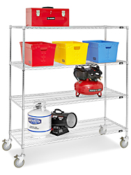
  Enlarge
  HEAVY DUTY
  Tough, maneuverable carts move large loads.
  - 4 Shelf – Longer posts give more space for larger items. Greater capacity for less trips.
  - Easy to clean; won't collect dirt.
  - Shelves adjust in 1" increments.
  - 5" locking swivel casters included.
  - NSF certified.
  - Optional Wire Shelving Accessories available.

MODEL  NO. | DIMENSIONS  W x D x H | SHELF  QTY. | CAPACITY  (LBS.) | PRICE EACH |  | WT.  (LBS.) | ADD TO  CART
 |  |  |  | 1 | 3+ | WT.  (LBS.)
H-3158 | 60 x 24 x 69" | 4 | 1,000 | $289 | $279 | 110

SHIPS UNASSEMBLED VIA UPS

